**Pragramme Name and Code: __**PN1I/22101**_______________ Academic Year : 2020-2022**

**Course Name and Code: _**Printer Technology**___________________ Semester : First**

**A STYDY ON**

The___prepare__using_different_idioms_with_their_origin_and_their_contextual_usage_(any_20)____

**MICRO PROJECT REPORT**

**Submitted in Oct/Nov 2017 by the group of..........students**

|  |  |  |  |  |
| --- | --- | --- | --- | --- |
| **Sr**  **No** | **Roll no**  **(Sem-I)** | **Full name of students** | **Enrollment**  **No** | **Seat No**  **(Sem-I)** |
| 1 | 17 | Tejas Madkar | 2004260017 |  |
| 2 | 18 | Abhishek pawar | 2004260018 |  |
| 3 | 19 | Aditya Tokekar | 2004260019 |  |
| 4 | 20 | Farin Pathan | 2004260020 |  |
| 5 |  |  |  |  |
| 6 |  |  |  |  |
| 7 |  |  |  |  |
| 8 |  |  |  |  |
| 9 |  |  |  |  |
| 10 |  |  |  |  |

Under the Guidance of

**Prof. shri. K. G. Suryawanshi**

**In**

Three years Diploma programme in Engineering & Technology of Maharashta

State Board of Technical Education Mumbai ( Autonomous)

ISO 9001:2008(ISO-IEC-27001:2013)

**MAHARASHTRA STATE BOARD OF**

**TECHGNICAL EDUCATION, MUMBAI**

**Certificate**

This is to cerify that Mr. / Ms Tejas Amol Madkar_____________________

Roll No: 17 **First Semester** of Printing Technology____________________

**Diploma Programme in Engineering & Technology –Pune Vidyarthi Griha-Pune**

Has completed the **Micro Project** satisfactorily in subject **English (22101)** in the

academic year 2021-2022 as prescribed in the MSBTE curriculam of I scheme.

Place: Pune Enrollment No: 2004260017

Date: 28/02/2021

**Project Guide Head of the Department Principal**

Yogeshwari mam Parmeshwar Shinde

**Index..**

|  |  |  |
| --- | --- | --- |
| **Sr.No** | **Title** | **Page No** |
| 1 | Abstract and Introduction |  |
| 2 | Main Body/ Content |  |
| 3 | Conclusion / Learning Outcomes |  |
| 4 | Literature Review and Reference |  |
| 5 | Weekly Work / Progress Report |  |
| 6 | Evaluation Sheet |  |

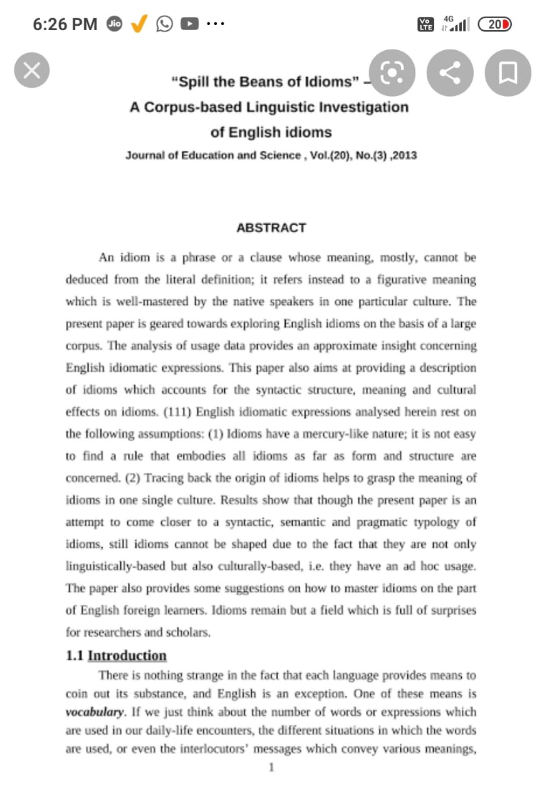

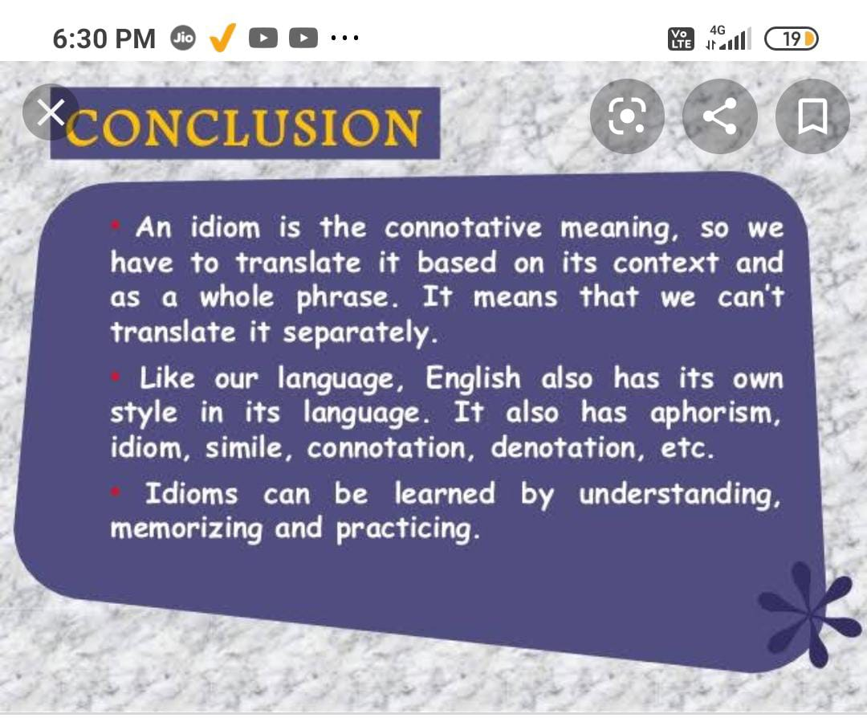

**Weekly Work/Progress Report…**

|  |  |  |  |  |  |  |  |  |  |  |  |  |  |
| --- | --- | --- | --- | --- | --- | --- | --- | --- | --- | --- | --- | --- | --- |
| **Week**  **NO** | | **Date** | | **Timing** | | | | **Work or activity Performed** | | | | **Sign of**  **The grade** | |
| |  | | --- | | **Details of 16 Engagement of the student**  **Regarding completion of the project** | | |  | | **From** | | **To** | | **Duration**  **In hour** | |  | |  | |
| 1 | | 28/ 12/2020 | |  | |  | | One  hour | | Discussion and Finalization of the  Project title | |  | |
| 2 | | 4 / 1 / 2021 | |  | |  | | Two  hour | | Preparation and Submission of  Abtstracts | |  | |
| 3 | | 11 / 1 /2021 | |  | |  | | Two  hour | | Literature Review | |  | |
| 4 | | 18/ 1 / 2021 | |  | |  | | Two  hour | | Collection of Data | |  | |
| 5 | | 25/1 / 2021 | |  | |  | | Two  hour | | Collection of Data | |  | |
| 6 | | 1 / 2 / 2021 | |  | |  | | One  hour | | Discussion and outline of content | |  | |
| 7 | | 8 / 2 / 2021 | |  | |  | | Two  hour | | Rough Writing of the Project  Content | |  | |
| 8 | | 15 / 2 / 2021 | |  | |  | | One hour | | Editing and proof Reading of the  content | |  | |
| 9 | 22 / 2 / 2021 | |  | |  | | Two  hour | | Final Completion of the Project | |  | |  |
| 10 | 1 / 3 / 2021 | |  | |  | | One  hour | | Seminar Presentation Viva-vice  Assessment and Submission of  Report | |  | |

**Name of the Project Guide** Mr. K. G Suryawanshi

Lecturer in English and Communication Skills

**ANNEXURE-II**

**Academic year:2021/2022 Name of faculty:** Yogeshwari mam

**Sem:** Semister 1___________ **Pragramme name and Code:** Pn1I/22101

**Course Name:** Printing Technology **Course Code:__________________________**

**Name of the Student: Tejas Madkar , Abhishek Pawar , Aditya Tokekar . Farin Pathan**

**Title of the project**: **Prepare a Collage using different idioms with origin and their contextual (any20)**

* **Cos Addressed by the Micro Project**

1. **___To_form_grammatically_correct_sentences_____________________________________________________________**
2. **___Summerarise_the_data_on_given_topic_____________________________________________________________**
3. **___To_represent_idea_or_opinion_on_given_subject_________________________________________________________**

* **Major Learning Outcomes achieved by student by doing the Project**

1. **Practical Outcomes**

**To develop reading, speaking , listening and writing skills while knowing, representing the given subject**

**Unit outcomes ( in cognitive domain)**

**To enhance language sills of learner and also creative use of language**

**( c) Outcomes in affective domain**

**To function as team member__________________________________**

**To share ideas and attitudes___________________________________**

* **Comment/ Suggestion about team work/leadership/inter-personal communication(if any):**

The work how should be done. About any improvement in project.

Any changes in project. This is the communication of a leader

* **Any other comment:**
* **Marks:**

**Name of the students: Tejas Madkar, Abhishek Pawar , Aditya tokekar , Farin Pathan**

1. Marks for Group work:
2. Marks Obtained by the individual based on via **( Prof. ………………………..)**
3. Total Mark ( A+B) = Signature with name and designation of the Faculty Member